Name:Rajdeep Sarkar
Roll:UG/02/BTCSECSF/2023/008
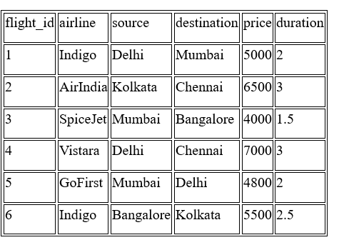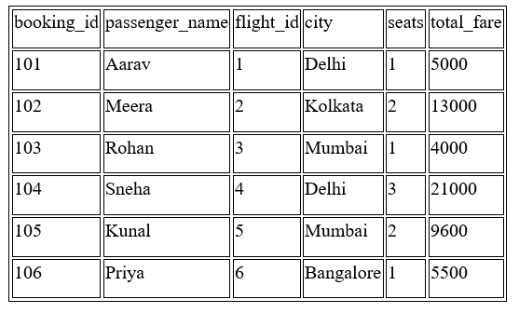
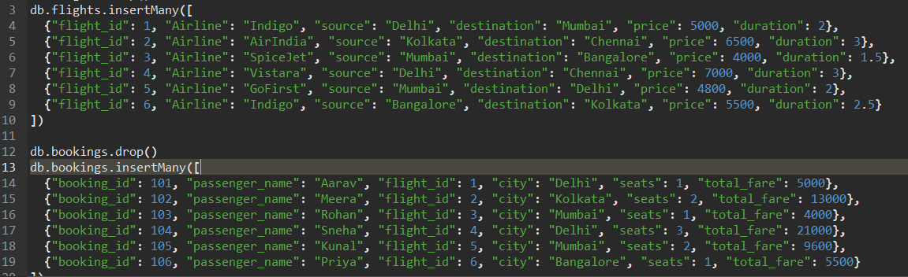
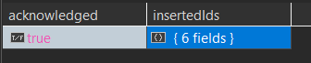

Q1. Display all flights
db.flights.find({});
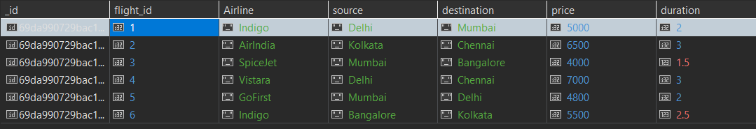
Q2. Display passenger_name and city from bookings
db.bookings.find({}, {passenger_name:1, city:1, _id:0});
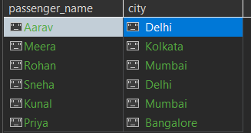
Q3. Find flights where source is Delhi
db.flights.find({source:"Delhi"});
Q4. Find bookings where seats = 1
db.bookings.find({seats:1});
Q5. Sort flights by price in ascending order
db.flights.find({}).sort({price:1});
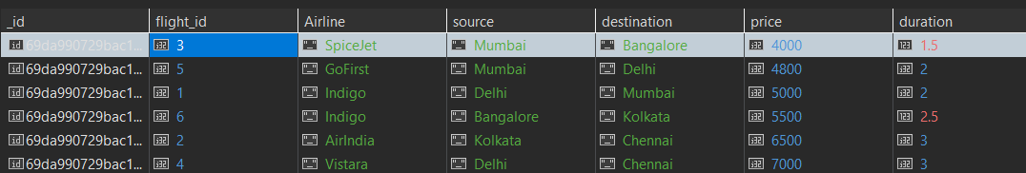
Q6. Display top 2 bookings with highest total_fare
db.bookings.find({}).sort({total_fare:-1}).limit(2);
Q7. Find flights where price is greater than 5000
db.flights.find({price:{$gt:5000}});
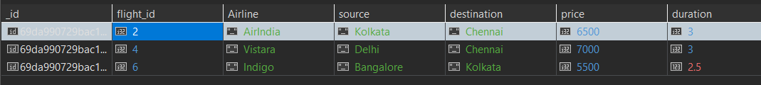
Q8. Display flights where destination is not Chennai
db.flights.find({destination:{$ne:"Chennai"}});
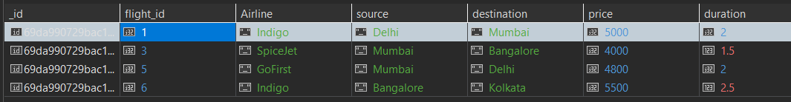
Q9. Find bookings where seats are between 1 and 2
db.bookings.find({seats:{$gte:1, $lte:2}});
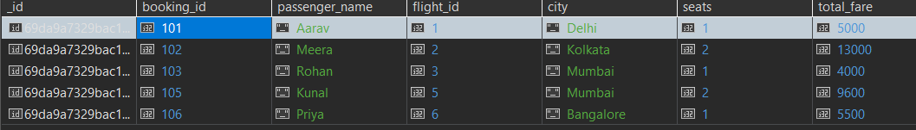
Q10. Update price by +500 for flights of airline "Indigo"
db.flights.updateMany({airline:"Indigo"}, {$inc:{price:500}});
Q11. Delete bookings where seats are greater than 2
db.bookings.deleteMany({seats:{$gt:2}});

Q12. Find total fare collected city-wise (Aggregation)
db.bookings.aggregate([
{$group:{_id:"$city", totalFareCollected:{$sum:"$total_fare"}}}
]);
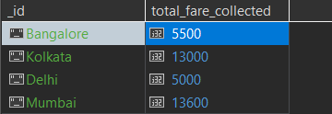
Q13. Find average flight price per airline (Aggregation)
db.flights.aggregate([
{$group:{_id:"$airline", averagePrice:{$avg:"$price"}}}
]);
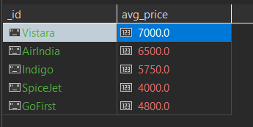
Q14. Display airlines where average price is greater than 5500
db.flights.aggregate([
{$group:{_id:"$airline", averagePrice:{$avg:"$price"}}},
{$match:{averagePrice:{$gt:5500}}}
]);
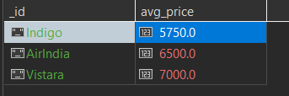
Q15. Find maximum total_fare among bookings for each city
db.bookings.aggregate([
{$group:{_id:"$city", maxFare:{$max:"$total_fare"}}}
]);
